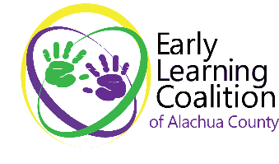
4424 NW 13th Street
Ste A5
Gainesville, FL 32609
Office: 352-375-4110

PUBLIC LEGAL NOTICE ADVERTISEMENT

Request for Proposal RFP # 2025-001
Leased Office Space
For Early Learning Coalition of Alachua County

The Early Learning Coalition of Alachua County (ELCAC) located at 4424 NW 13th Street, Ste A5, Gainesville, FL 32609 is seeking Proposals from qualified property owners or representative to provide leased office space within Alachua County, Florida. This space will serve as the Coalition’s headquarters and operational offices. A.
The Early Learning Coalition is a not-for-profit corporation organized under the laws of the State of Florida and has been determined exempt by the Internal Revenue Service under the provision of IRS Code, Section 501(c)(3). The Florida Office of Early Learning has certified the Coalition as a local early learning coalition for the purposes of implementing programs authorized by Florida Statute Chapter 1002. Our principal function is the provision of oversight, and policy guidance to the early childhood School Readiness and Voluntary Prekindergarten Education systems in Alachua County, Florida
The ELCAC will select a proposer that is qualified to provide the services described in the RFP.

Important Dates:

Date RFP Available: | April 16, 2025, at elcalachua.org/request-for-proposal
Written Inquires Email To: | April 21, 2025, by 5:00 PM EST  Fiscal-invoices@elcalachua.org  ATTN PROCUREMENT RE: RFP # 2025-001 in subject line
Response to Inquiries | April 23, 2025, by 9:00 AM EST  Responses will be posted to website
Proposal Deadline | April 30, 2025, by 5:00 PM EST
Mail or Deliver to: | Attn: Procurement RE: RFP # 2025-001  Early Learning Coalition of Alachua County  4424 NW 13th St Ste A5  Gainesville, FL 32609

